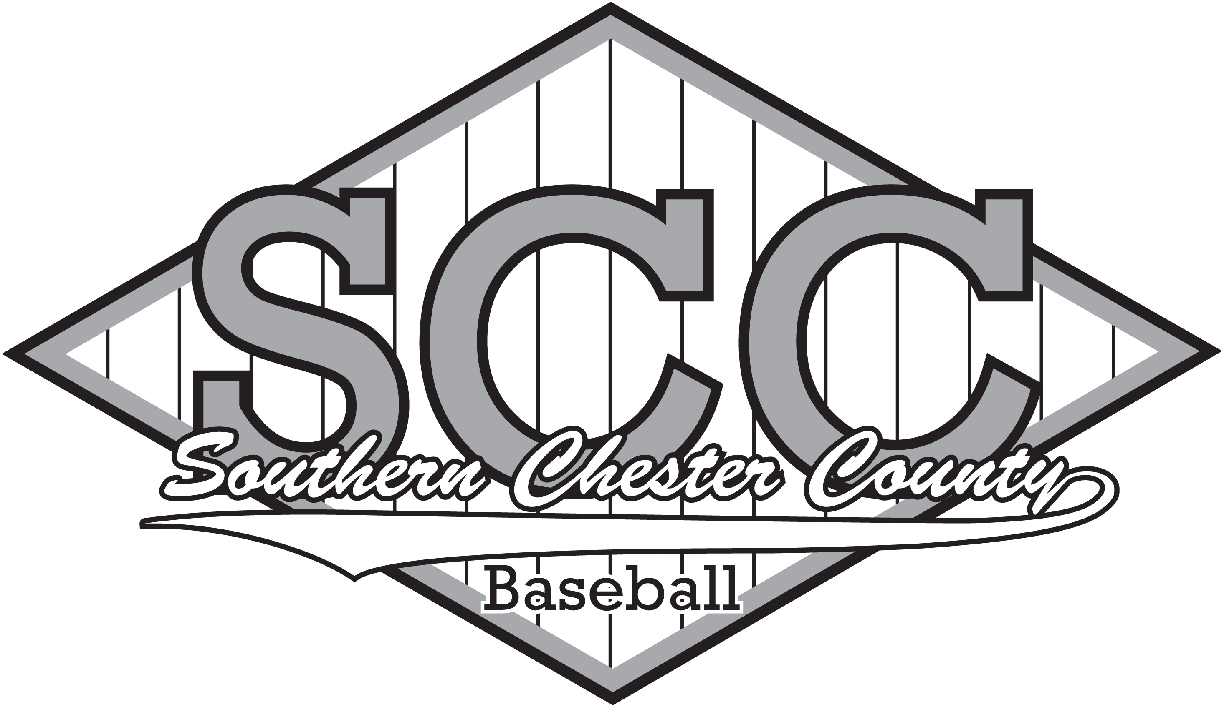

FIELD RULES
- Park in designated parking areas. No parking in Parkesburg on park side of Gay Street
- SCCBRL is not responsible for tickets or cars damaged by hit balls.
- Spectators are not allowed to sit or stand directly behind home plate.
- Spectators are not allowed on the bench, dugouts, in warm-up areas, or on the field.
- Remind spectators to be aware of foul balls and players swinging bats or hit-sticks.
- Bats and hit-sticks can only be used in designated warm-up areas, away from foot traffic and spectators.
- Please place all trash, cans, and bottles in the trash bins or dispose at home.
- Coaches should police the stands and bench areas after games to clean up any trash.
- Encourage players and family to take trash with them.
- There is no smoking or alcohol allowed on any SCCBRL, EBYA, or URA field, in the stands or spectator areas.

FIELD MAINTENANCE
- Home team is responsible for setting up the field before the game:
  - Walk the field and fence to remove any trash or debris.
  - Rake out any standing water and repair any depressions or uneven spots in the infield.
  - Drag the infield is needed
  - Set the bases and cover open base posts
    - T-Ball, Rookie, Minors: 60’ Bases, 48’ Pitching Mound
    - Majors: 70’ Bases, 50’ Pitching Mound
    - Babe Ruth: 90’ Bases, 60’ Pitching Mound
  - Line the base paths
  - Rake and line the batter’s box
  - Minors, line a 10’ radius around the pitching mound
  - Majors, line a 6’ radius around home plate
- Visiting Team is responsible for restoring the field after the game:
  - Storing the bases (where required) .
  - Dragging the infield.
  - Batter’s boxes and pitching mound should be raked and holes filled and tamped.
  - Walk the field and stands to remove trash.
  - Return all field equipment to the shed and lock the shed.

MEDICAL EMERGENCIES
- Player safety should be everyone’s number one concern.
- Ice packs and basic first aid kits will be distributed to the coaches.
- Players that listed any allergies or medical conditions are included on the roster. Coaches should be aware of any medication or allergies that players may have.
- Players are required to provide the league with medical insurance carrier and policy numbers. These are maintained by the league.
- Players with severe allergies should have an epi-pen nearby at all times. Bees are a problem at most fields.
- Players with asthma, diabetes, or similar conditions should have inhalers or medication nearby at all times.
- If a player is injured during play, all players will drop to a knee as soon as time is called.
- Coaches should respond to the player and do a quick assessment of the situation. Check to determine if the player is unconscious, not breathing or bleeding.
- Severely injured players (loss of consciousness; not breathing; heat stroke; compound fractures; head, neck or back injuries; or severe cuts) require immediate 911 call for assistance.
  - Do not attempt to move any severely injured player until an EMT arrives.
- Players that get a blow to the head should be checked for signs of concussion or other head injury: loss of consciousness, black outs, confusion, dizziness, loss of balance, vision or speech issues, contusions, swelling, etc. Players that experience any type of head injury should be removed from the game and moved to the bench for observation for the remainder of the inning. Parents should be contacted and Players can only return with the approval of the parents and the umpire.
- Players with minor injuries that require attention or observation should be removed from the field and a substitution made until the injury is attended to
- Players removed from the field or base path must sit out the remainder of the inning before returning.
- If an injured player is removed from the lineup, that batting spot will be skipped with no penalty to the team batting.

UNIFORMS AND EQUIPMENT

UNIFORMS
The league will provide the following uniforms:
Division | Hats | Shirt | Pants | Socks
T-Ball | Team Hat | T-shirt, team logo | No | No
Rookie | Team Hat | T-shirt, team logo | Grey draw string | Team Color
Minor | Team Hat | 2 button jersey, team logo | Grey belted elastic legs | Team Color
Major | Team Hat | 2 button jersey, team logo | Grey belted elastic legs | Team Color
Babe Ruth | Common Chesco league hat | 2 button jersey with ChesCo logo in team color: Grey, Black, Rust | Player supplies: Grey open leg pants with black leg stripe | Black
All players are encouraged to wear an athletic supporter (cup) to games and practices. Catchers are required to wear a cup at all times.
Players are encouraged to have baseball cleats (soccer cleats are ok, metal cleats are only allowed in Babe Ruth division). Athletic shoes can be worn, but boots and hard sole shoes are not allowed.
Players are encouraged to purchase a ¾ sleeve baseball t-shirt or compression shirt s and wear this underneath their jersey.
White long sleeve shirts or sweatshirts are not allowed to be worn underneath jersey, especially for pitchers.
During cool weather dress in layers - a turtleneck, crewneck sweatshirt and/or fleece is recommended underneath the jersey – hooded sweatshirts or jackets are not recommended. Coats, jackets and sweatshirts are not allowed to be worn over the jersey during games. Coats, jackets and sweatshirts can be worn on the bench.
Slide shorts are optional and can be worn underneath the uniform pants.
Jewelry is prohibited. Players, coaches and managers shall not wear jewelry. Medical alert and religious bracelets or necklaces are not considered jewelry.

BATS
Players of this age generally need a 26” – 32” bat:
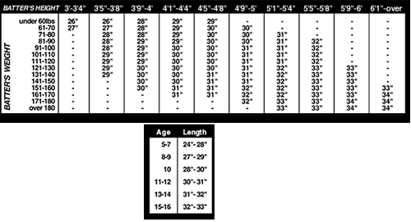
Players can use their own bats that meet the following specifications:
- Bats should be stamped approved for Babe Ruth League or Cal Ripken League.
- All bats should have grips in good condition and should not be dented or cracked.
Cal Ripken:
- The bat may not exceed 33"in length, and the bat barrel may not exceed 2¼" in diameter.
- Only 2¼" barrel non-wood bats marked BPF 1.15 will be allowed.
- Wood 2 ¼" barrel bats are allowed.
Babe Ruth:
- The bat may not exceed 34" in length, and the bat barrel may not exceed 2 5/8" in diameter.
- All aluminum/alloy barrel bats and all composite handle (only) aluminum/alloy barrels are allowed.
- Only composite barrel bats certified and marked BBCOR .50 will be allowed.
- Wood barrel bats conforming to the specifications of Official Baseball Rule 1.10 are allowed.
Players should mark their bat with tape or their name – a lot of players/teams have the same bats. Bats must be kept in a player’s bag or hung with the other bats.
The league provides a few bats of various sizes to each team. If a coach thinks a player’s bat is too long/short or too heavy for the player, we may ask the player to use a more appropriate bat.
Only players on deck are allowed to have a bat in hand.
Bats are to only be swung in the batter’s box and designated warm up areas.

PRACTICE CLOTHES
Players should wear their game shoes, athletic pants, old baseball pants or old jeans that they can slide in, and t-shirts/pull-over sweatshirts to practices. Game jerseys and pants should not be worn to practice.
Shorts should not be worn to practice. Bulky coats and hooded jackets are not recommended for practice – wear layers like theywould wear to a game in the same conditions. Avoid sweatshirts with zippers.

BAT/EQUIPMENT BAGS
Bags are optional. If players bring a bag to practice or a game, they must hang it up on the fence or leave it with their parents. Bags should not be lying around the bench where they can be tripped over.

BASEBALL GLOVES
Each player must provide their own baseball glove. Gloves should be appropriate size for the player’s hand and not be too large. Specialty gloves (1st base, catcher) are permitted, but players should practice with these gloves.

BATTING GLOVES
Players are permitted to wear batting gloves. If they are going to wear gloves in the game, they should bring them to practice and wear them during batting practice.
Players should leave gloves on while running bases and not be distracted with taking gloves off until reaching the bench. Removed gloves should be place in the player’s pocket.
In the field, batting gloves can be worn underneath their baseball glove but cannot be worn on their throwing hand, except in cold weather.

HELMETS
Helmets must be worn at all times when batting, base running and warming up with a bat.
The league provides 2-3 helmets. Players can provide their own helmet. Helmets with facemasks are permitted. Player helmets should be kept in a bag or hung up with the other helmets.

CATCHER’S GEAR
The league provides a full set of catcher’s protective gear for Rookie and above: helmet, chest protector, & shin pads. The league provides a right-handed catcher’s mitt. Catcher’s helmet and pads must be worn at all times when catching. Players can provide their own catching gear, but it must be kept in their bag when not being worn.

Web Sites and Social Media

SCCBRL LEAGUE WEBSITE:
http://www.sccbrl.org/
League’s official website has latest news, schedules, and standings.

BABE RUTH LEAGUE WEBSITE:
http://www.baberuthleague.org/
The official website for the Babe Ruth League and Cal Ripken Division.

SCCBRL FACEBOOK PAGE:
https://www.facebook.com/SCCBRL
This page is open to any Facebook user and is administered by the league. Used to post official league announcements and other information. Click Like to follow the page.

SCCBRL LEAGUE FACEBOOK GROUP:
SCCBRL – Southern Chester County Babe Ruth League
This group is an open group for league families and players. The SCCBRL group requires a member of the group to admit them to the group. Members of the SCCBRL community can use the group to share pictures, videos, and posts. You may leave status updates and comments on the page. The group is monitored by the Board.

GAME-TIME FOOD AND DRINK
Only food that should be on the bench is healthy snacks, energy bars, fruit and seeds.
Players are encouraged to bring a water bottle or a bottled sport drink (no sodas) to games and practice. Water is best.
Avoid high sugar sports drinks. Cut Gatorade with 50% water to avoid sugar spikes.
Do not leave the bench to get food or drinks without first telling a coach. You will not be allowed to leave the bench to purchase concessions.

PRE-GAME MEAL
- Eat a pre-game meal 1-2 hours before game time.
- Meal should be balanced: 40% complex carbohydrates, 30% protein, and 30% fat.
- Avoid foods high in saturated fats and simple sugars – see list of recommended and avoided foods. Sugary foods and drinks can lead to sugar crash during the game.
- Drink at least 16 oz of water with your meal.
- Avoid caffeine and carbonated drinks several hours before the game.
- Avoid sports drinks before the game – these have lots of sugar and will lead to a sugar crash during the game.
Recommended Pre-Game Foods | Foods to Avoid
Pastas – Wheat and whole grain pasta is best. Avoid cream sauces high in fat. | Cakes, cookies, brownies, pies and other baked goods
Breads – Wheat, rye, pumpernickel and whole grain breads are best | Donuts and pastries
Cereal – whole grain without sugar | Candy
Oatmeal | Gummies and fruit snacks
Bagels | Cola and other sodas, including diet soda
Fruits | Lemonade, Kool-Ade, Hi-C and other high sugar drinks
Vegetables | Tea and coffee – no caffeine
Salad | Fried chicken, chicken nuggets, French fries and other fried foods
Yogurt | Burgers
Beans | Hot dogs and sausages
Peanut Butter | Processed meats – bologna, salami, etc
Eggs | Canned fruit in heavy syrup
Cheese | Pudding
Chicken, Turkey, Ham, Lean Roast Beef or Roast Pork | Ice Cream
Fish and canned tuna – baked or grilled | Sugary cereal
Beef jerky | Chips and other snack foods
Dried fruit
Granola and granola bars
Nuts
Mac & Cheese
Canned Pasta
Rice – brown rice is better than white
Water, Water, Water

PITCHING

PITCH COUNTS
A pitch count is used, limiting the pitcher to a fixed number of pitches per game and in a week
- Maximum pitches allowed in a game/day: 85
- Maximum pitches allowed in a week: 120

Pitch Count | Required Days of Rest
1-20 | No (0) Calendar Days
21-35 | 1 Calendar Day
36-50 | 2 Calendar Days
51-65 | 3 Calendar Days
66-85 | 4 Calendar Days
85 | Maximum pitch count per game
Players must notify the coach if they are pitching in other leagues or for school teams

National Pitching Association recommended maximum pitch counts for 9-10 year olds:
- Per game: 65
- Per week (7 consecutive days): 100
- Per season: 1000

National Pitching Association recommended maximum pitch counts for 11-12 year olds:
- Per game: 75
- Per week (7 consecutive days): 100
- Per season: 1000

BALKS
- Pitchers must have one foot on or touching the pitchers rubber to start the throw.
- Pitchers making a move to throw to a base with runners on base must leave the rubber or a balk will be called. Left-handed pitchers must step towards first base or risk a balk.

PITCHING GRIPS
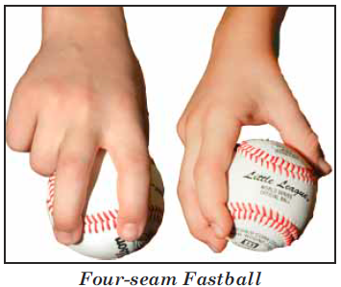

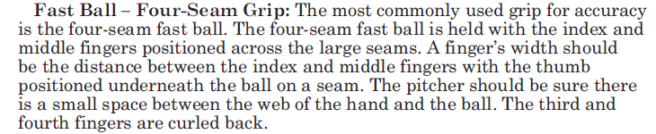

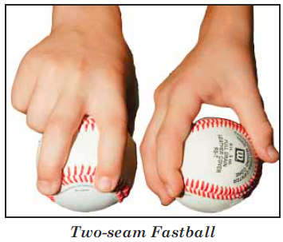
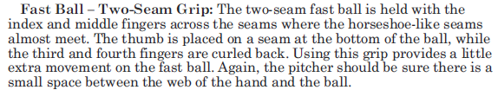

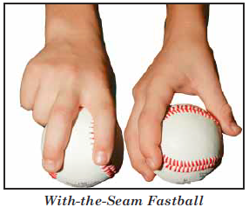
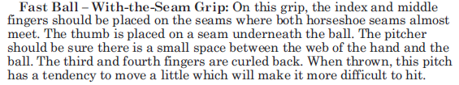

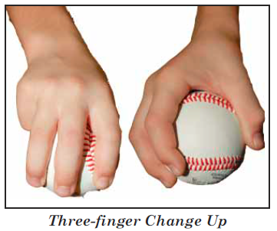
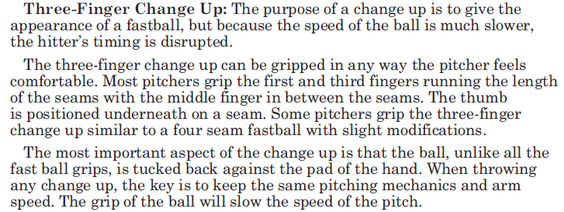

PITCHING STRATEGY
Most important pitch in baseball: This Pitch
Best pitch in baseball: Strike One
Pitchers should develop at least two pitches: fastball and change-up. A four seam fastball is a good pitch for the outside of the plate and a two seam fastball for the inside of the plate. A change-up or off-speed pitch makes the hitter adjust the swing to catch-up to the slower pitch. Pitchers can begin to throw curve/breaking balls, but proper form is important to prevent arm damage.
- Pitchers should have a goal to get a hitter off the plate in 3 pitches. 75% of hitters faced make outs when they see three pitches or less.
- Make the first pitch a strike. Working ahead puts more pressure on the hitter.
- Get the lead-off hitter out in every inning.
- Most important count is 1-1. Throw your best command pitch. Getting a strike on the next pitch increases the chance of a strikeout.
- A fastball can be thrown for any count. Use locations, inside/away, up/down to keep the hitter off-balance.
- Best counts to use a change-up: 2-1, 2-0, 3-1.
- Best curveball/slide counts: 0-0, 0-1, 0-2, 1-2.
- A 3-2 count requires a strike and puts the pressure on the pitcher to get the ball across the plate.
- A slow pitcher must work the inside of the plate and in-off more than a fast pitcher.
- A hitter close to the plate, locate away.
- A hitter off the plate, locate in.
- Stand up hitter likes the ball down, while a crouch hitter likes ball up.
- Hitter deep in the box is looking for a fastball; a hitter up in box is looking for a soft pitch.
- Pull hitter: hard in or soft away
- Opposite field hitter: hard, down in or hard, away off
- Inside out hitter: hard in, hard off, or soft away
- Steal situation: Off-speed pitch or breaking ball
- Hit and run situation: Fastball

KEY MAJOR RULES

HITTING
- A drop 3rd strike is a live ball and the hitter becomes a runner. The runner must be tagged out or the ball controlled by the 1st Baseman before the runner reaches the base or the runner is safe.
- Batters that step out of the batter’s box on the swing will be called out.
- The batter must make an effort to avoid being hit by a pitch.
- A ball that hits the bat of a batter that is avoiding a pitch is a live ball.
- If a runner is attempting to score from 3rd, the batter must move out of the batter’s box.
- Throwing the bat or helmets will result in a benching by the coach and may result in ejection by umpire.

BASE RUNNING
- Runners are allowed to lead. Runners off base can be tagged out at any time
- Runners can steal at any time and may steal home at any time.
- There is no limit to the number of bases on a steal, overthrow or misplayed ball.
- Runners that come in contact with the ball are out.
- Stealing home is allowed.

MERCY RULES
- Innings 1 to 5, teams hit until they have 3 outs or they score at least 5 runs in the inning.
- After 4 innings, a team that starts their half inning with a lead of 10 runs or more is declared the winner.
- In the last inning, there is no limit to the number of runs that can be scored. Inning ends with 3 outs for each team

